UI Design

For

Osmany Hall Messing System

What is User Interface?

In information technology, the user interface (UI) is everything designed into an information device with which a human being may interact -- including display screen, keyboard, mouse, light pen, the appearance of a desktop, illuminated characters, help messages, and how an application program or a Web site invites interaction and responds to it.

Why is it a good UI design important?

1. A good UI define interaction modes in a way that does not force a user into unnecessary or undesired actions.
2. It provide for flexible interaction.
3. Hides internal system complexities from general users.
4. A good UI present the software to the users in an appealing manner.
5. Good UI design helps to reach the goal behind the creation of a the software due to the easy acceptance by users.

Rules for a good UI design:

The Golden rules for a good UI design are as follows:

* Place the user in control
* Reduce the user’s memory load
* Make the interface consistent

UI Design for Our Software:

We are working to build software for controlling and overall management of Osmany Hall messing system which is presently done on manual measures. We tried to focus on the users and easy interaction procedure so that it everyone visiting and using the software gets a wonderful and complete experience

We look at some of the pages of our software below:

**Home Page:**

Our home page a scrolling home page with some main options authority , facilities, hall info, contact and login alongside. Its contains additional information such as rules and regulations, facilities and also history about hall. There is also

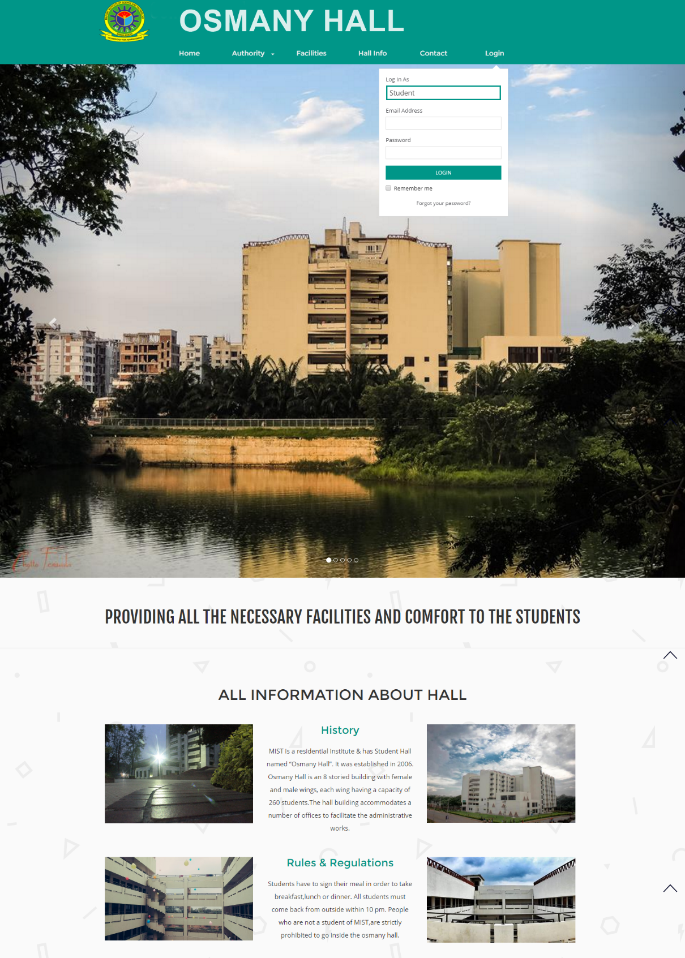

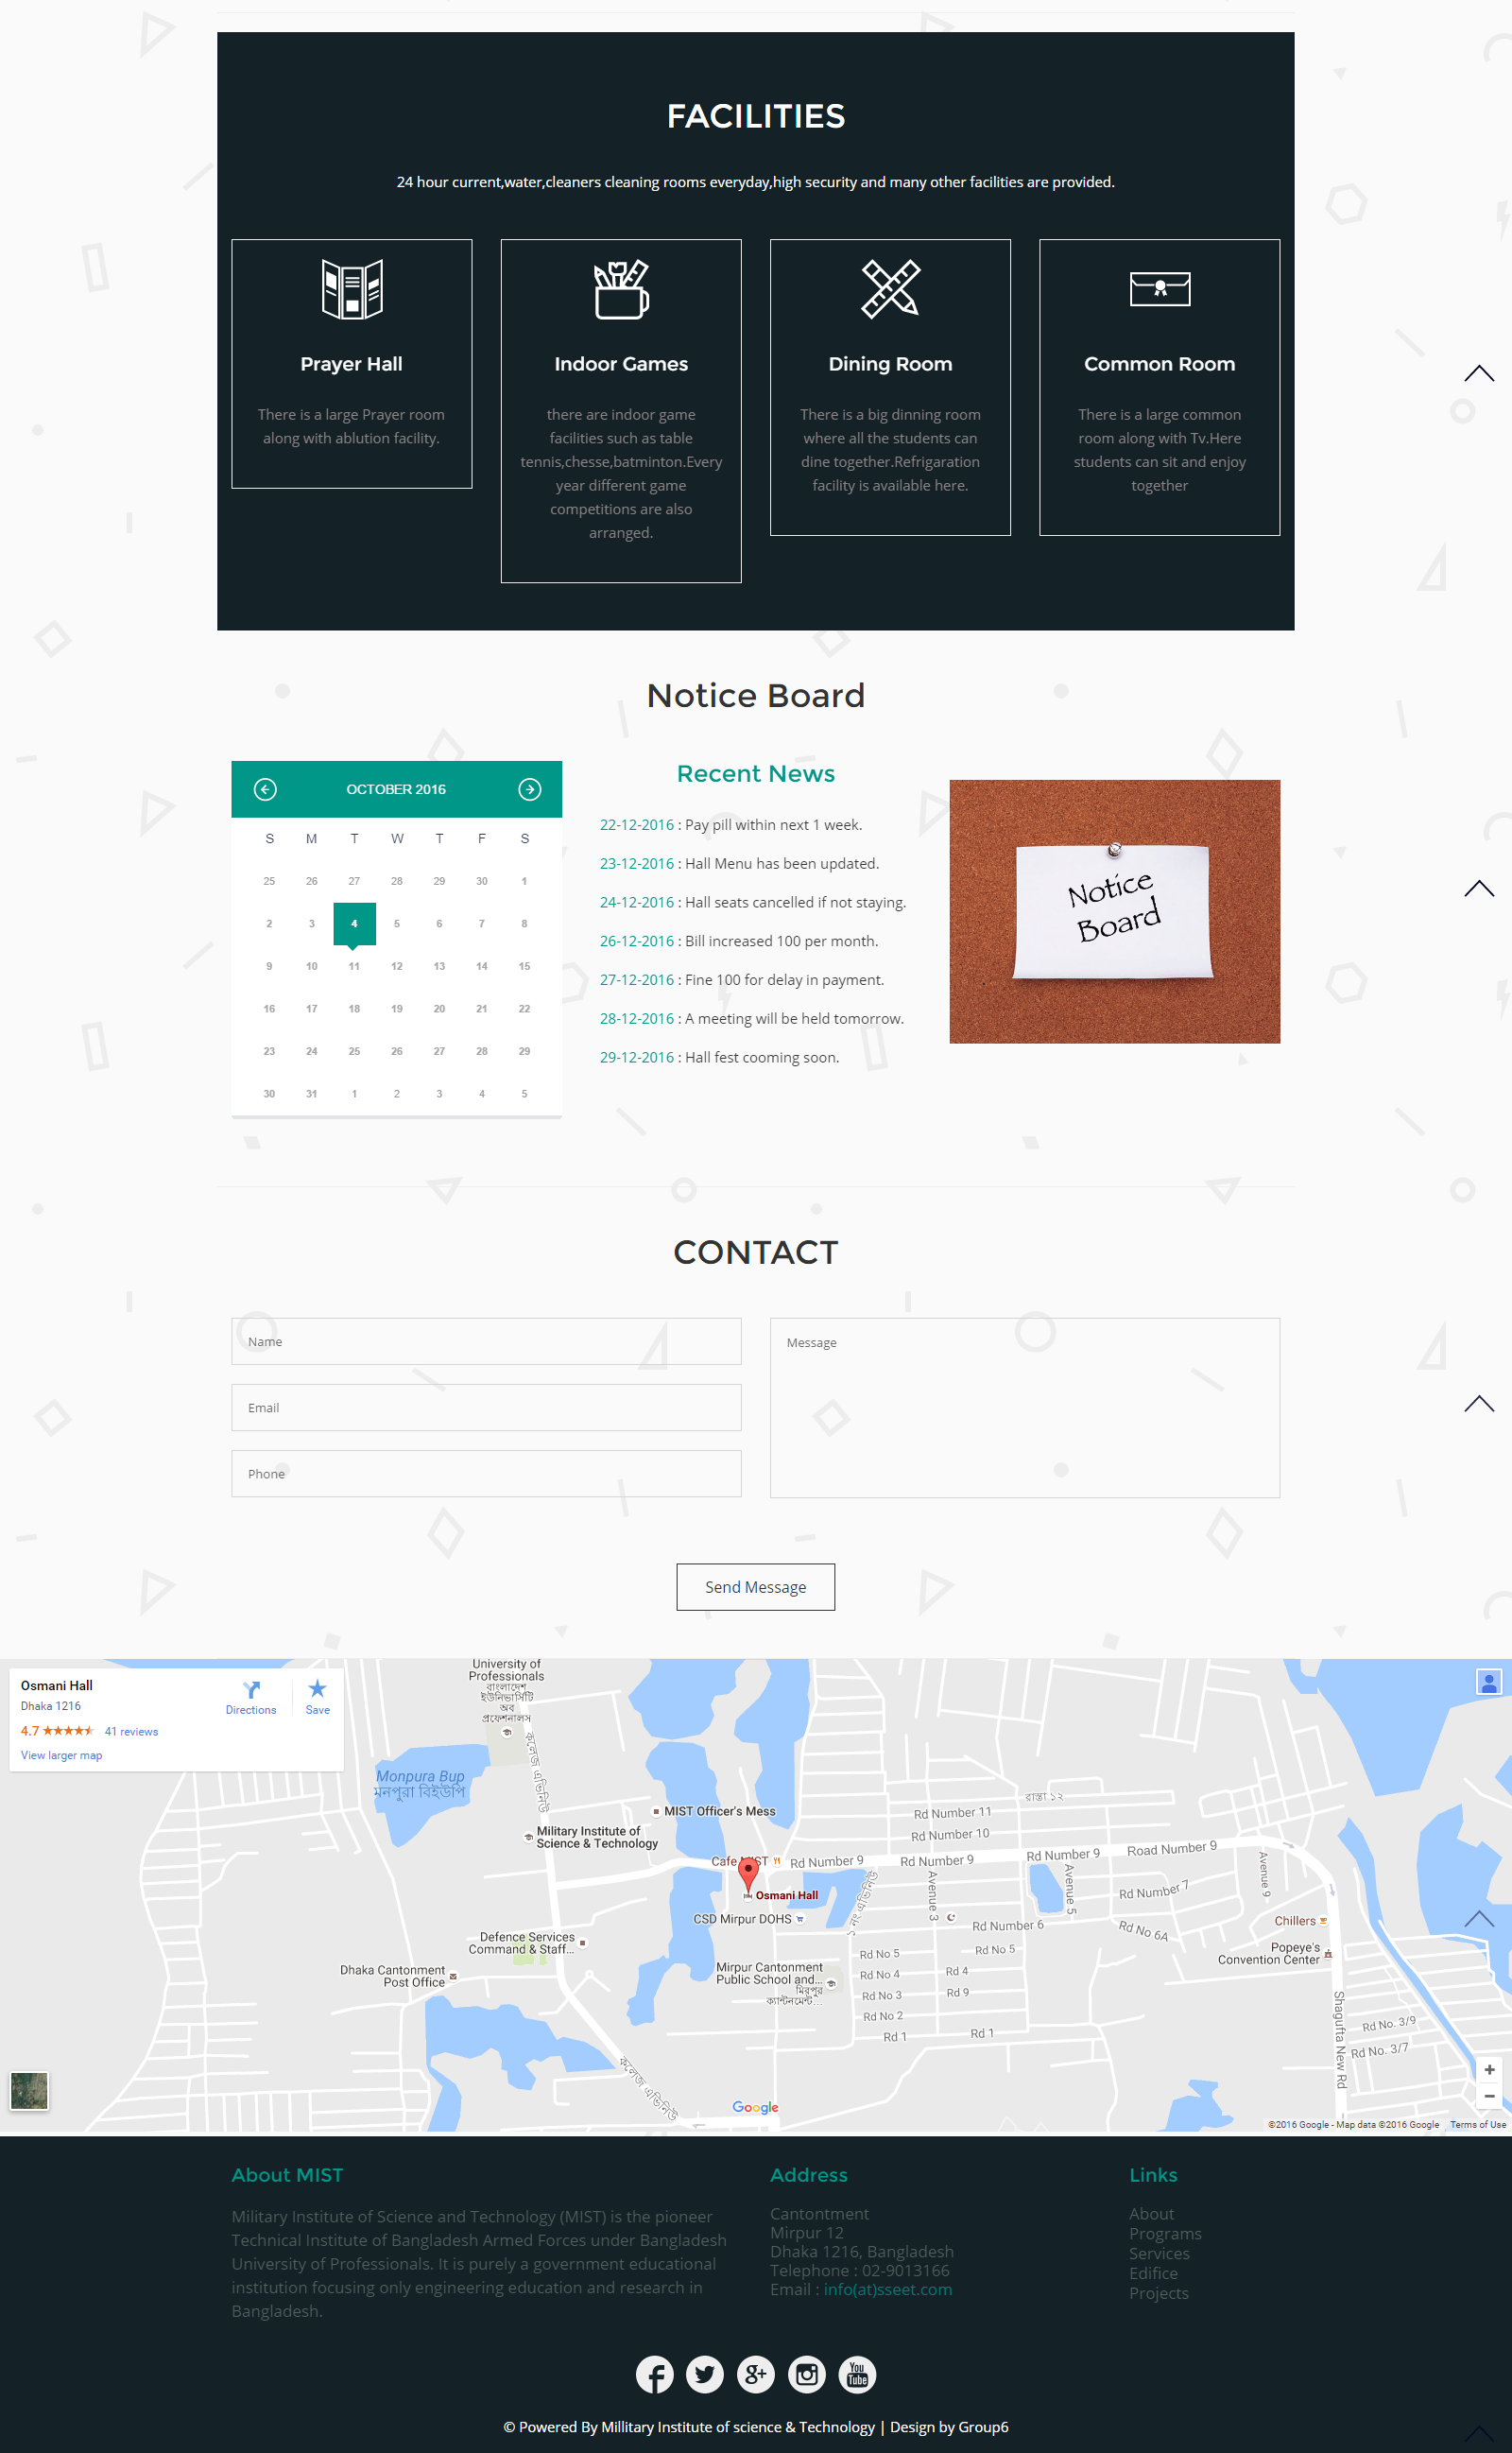

Mentioned about the hall facilities and important notices. The user can also give their feedback and submit to the website.

Hall Authority: This page contains information about hall staffs and their contact information. On any emergency or need the students can contact to the authority through the given info

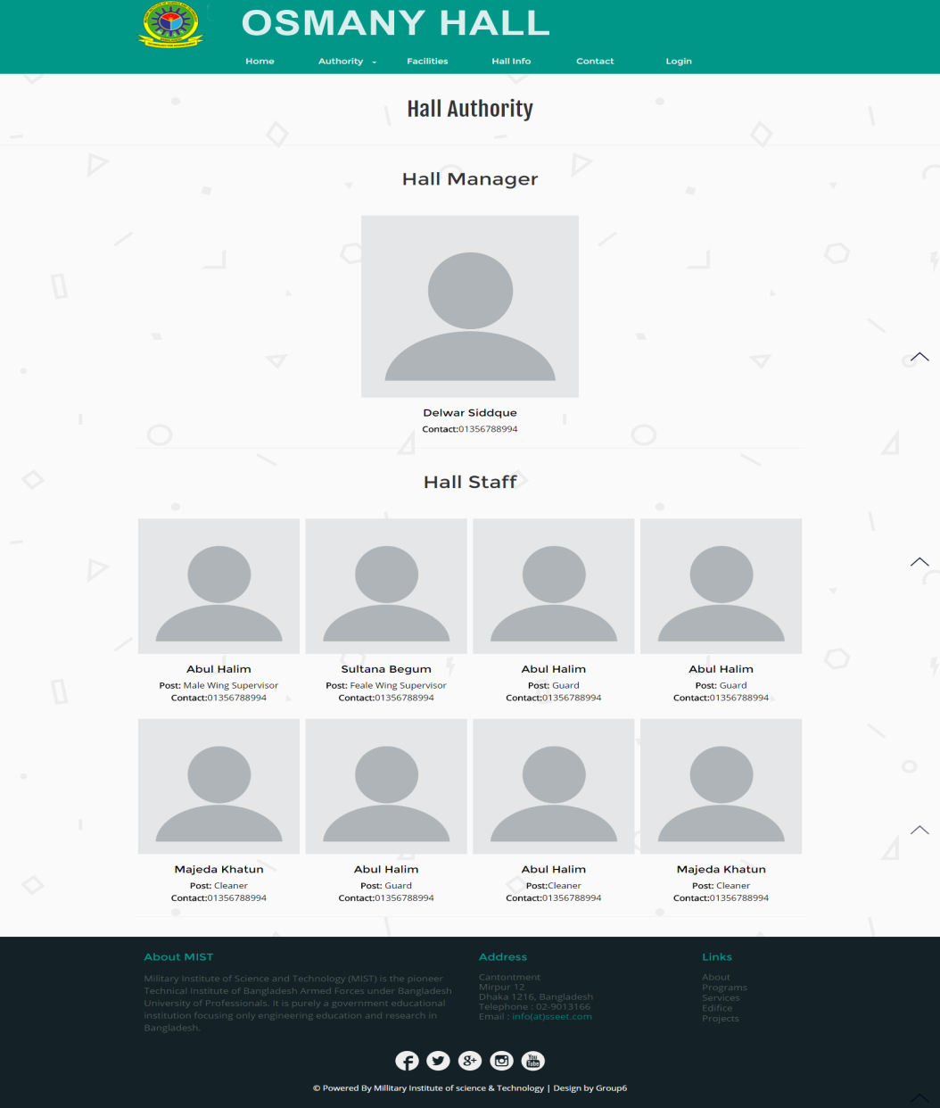

About Us: The about us page contains information about the aim with which the software has been created and information about the developers.

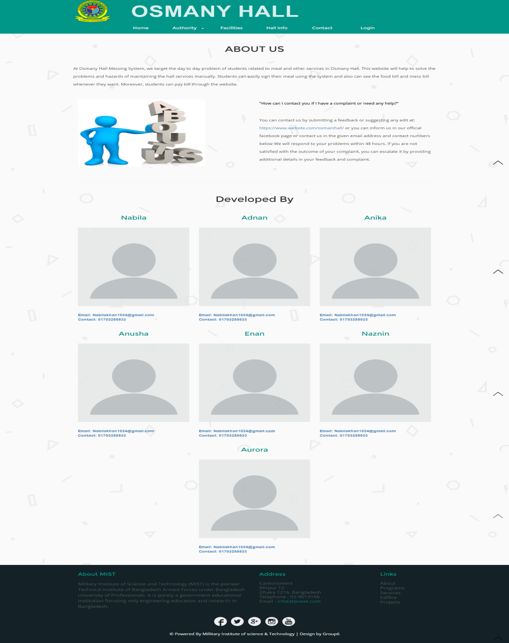

Hall Bill: This is the page displaying hall bill of an individual student. Once a student logs into his own account this page on clicking the hall bill option will appear. This displays the month and the bill for that month, tha paid amount, remaining or fines in a tabular form. On the left side the year bar is given from which particular year can be chosen.

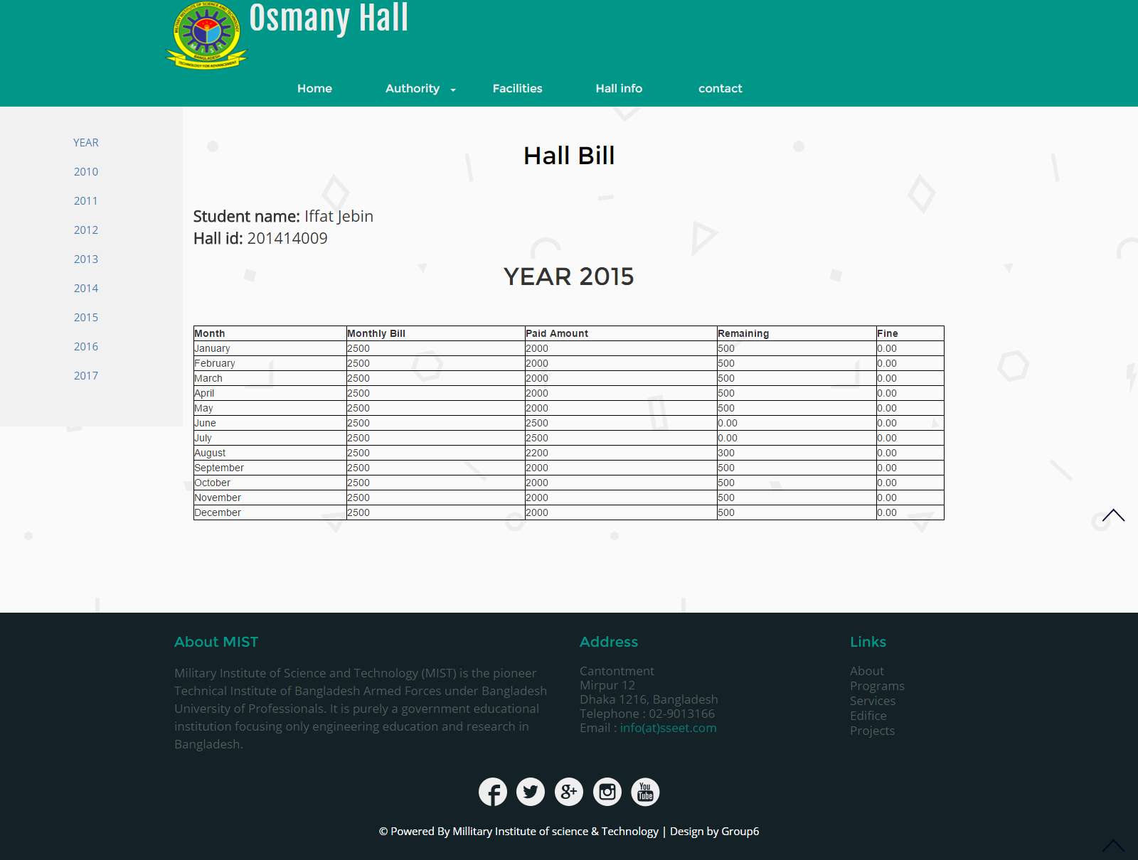

Mess Bill: On clicking the mess bill option student will be showed a page as below. It will display the months, the monthly bill, paid amount and remaining amount with fine. This page also provides a year bar on left side that carries info for those years, from this page on clicking home user can go to the home page.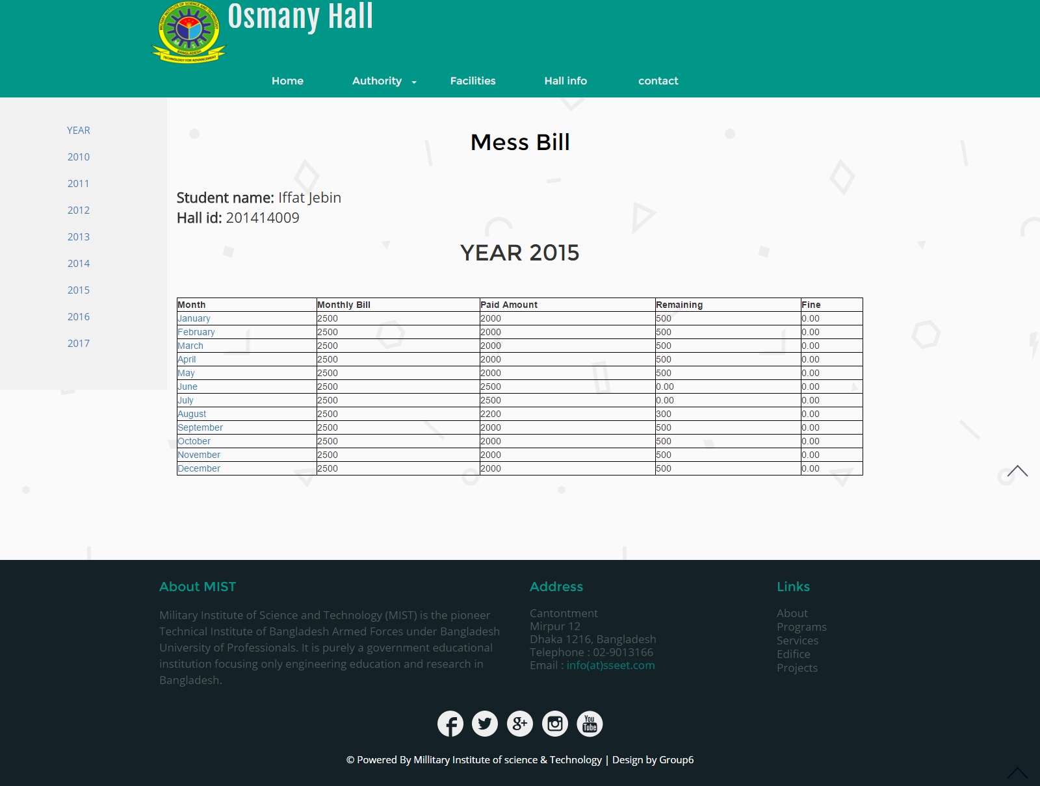

Students profile:

In the left side there is a navigation bar. Student profile contains basic info about student. Some of them can be updated by students and other by the hall manager. Student will be logged in as a student. He can sign mean for 3 different times a day

And view bill also.

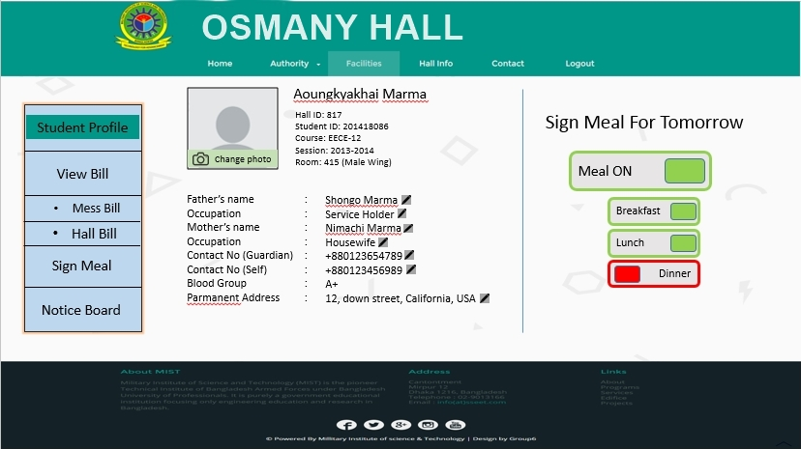

View bill:

For viewing bill there are two types of categories. Hall bill and mess bill.Mess bill is per the day. It shows the bill per time of the day individually and als shows the grand total of breakfast dinner and lunch. The mess bill is listed month wise.

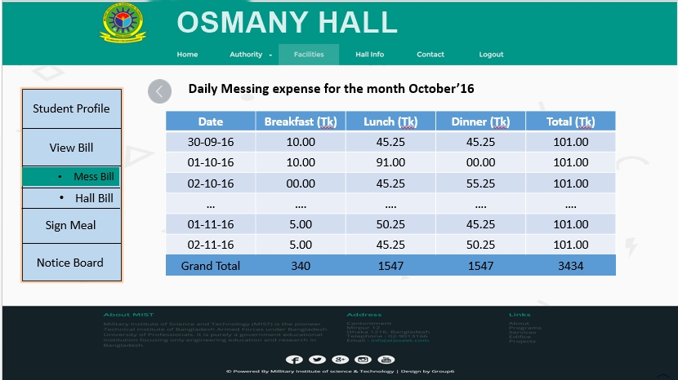

Managers profile:

Hall manager plays the vital role in our software system. Hall manager will open an account for students and will provide an id to them. This ID will help student to login into their account. He can manage, modify and update student information. He can update all the necessary information regarding the billing system as for example signing meal, total hall bills etc. he can provide notice and also create account of hall stuffs.

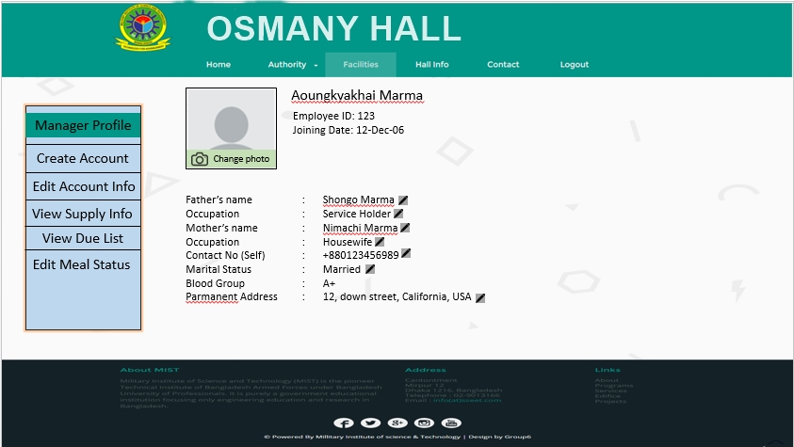

Hall staffs profile:

Hall stuffs are the assistants to hall manager. Basically they input the grocery item and maintain the meal system and other stuffs. There are nearly 50 staffs in both the wings. They have their individual accounts in the website opened by the hall manager through which they can update students’ info and input necessary information about students meal, and purchased grocery items. The page contains their basic informations and edit options for groceries and meal.

